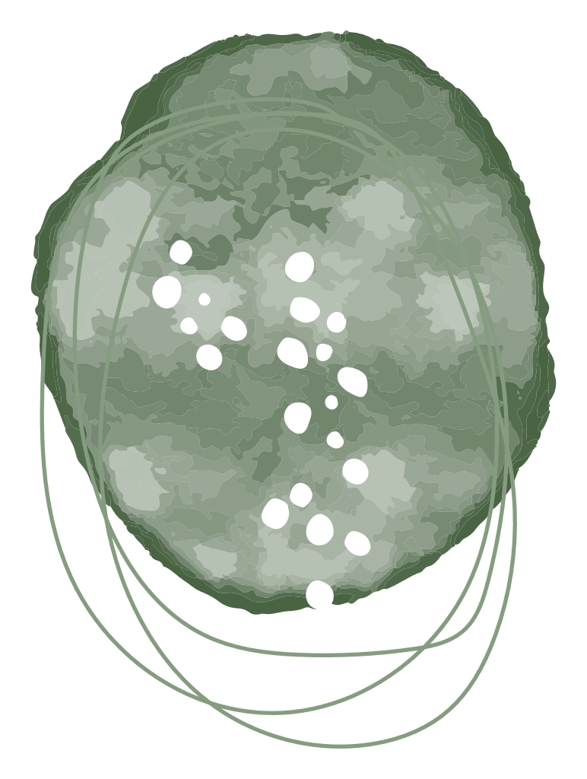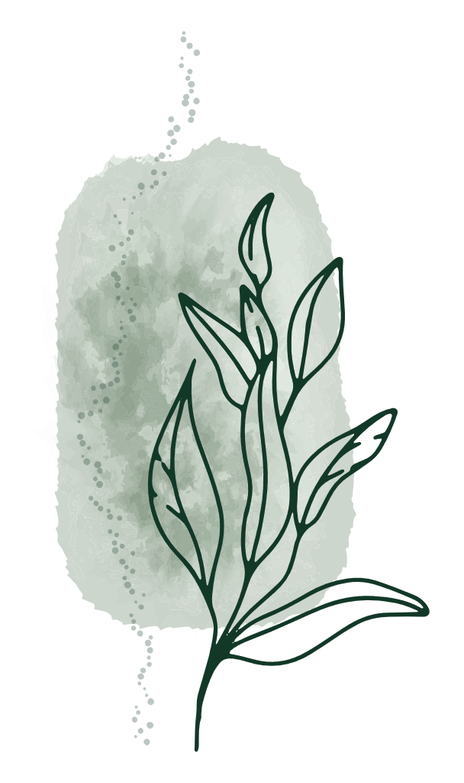

|  |  |  |
| --- | --- | --- |
| May Health Note  **Ways to reduce and manage stress**  Helping students develop and practice healthy living habits can help reduce stress and improve physical and mental health. Key areas to focus on include nutrition, exercise, sleep, recreational activities, and social relationships. Incorporate these activities and tips in your daily routine:  **Laugh:** A good laugh can help fight off stress, have fun together with your friends and family by watching a movie together, playing a game, or having a dance party. A smile and laughter are sometimes all you need to reset your mood.  **Exercise:** Going outside for a walk and getting some fresh air will help clear your mind and boost endorphins (the natural “feel-good” brain chemical). Being physically active can help you burn off the energy generated by stress.  **Quiet Time:** It is amazing how a few minutes of quiet time can make you feel better. Try listening to music, reading, coloring, or doing nothing at all. Everyone needs time to just relax.  **Practice mindfulness:** Mindfulness exercises, such as deep breathing or meditation, can help you relax and stay calm during stressful situations. It is all about being in the present moment.  **Stay hydrated:** Drinking enough water helps you stay alert and focused throughout the day. Keep a water bottle at your desk and refill it regularly.  **Healthy diet:** Healthy meals and snacks such as lean proteins, whole grains, fruit, nuts, and vegetables can help the body cope with stress more easily.  **Prioritize sleep:** Sleep is important for overall health and wellbeing. Children ages 6-12 years should aim for 9-12 hours, and teens ages 13-18 years of age should aim for 8-10 hours each night to help feel rested and refreshed. Sticking to bedtime routines will help kids relax at the end of the day.  **Connect with Family and Friends:** Spending time with your children and asking them how they feel builds positive relationships. Take time to connect with family and friends.  **Engage in activities:** It is important to have hobbies and interests to help you relax. These might include reading, playing a musical instrument, team sports, volunteering, or spending time with your pet.  **Resources:**  [**Classroom Mental Health**](https://classroommentalhealth.org/self-care/student/)  [**Stress Stoplight and How to help Kids Handle Stress (strongmindsstrongkids.org)**](https://strongmindsstrongkids.org/Public/Kids/Kids-Resources/Stress-Stoplight-and-How-to-help-Kids-Handle-Stress.aspx)  [**Back to school: 50+ student wellness resources - Kids Help Phone**](https://kidshelpphone.ca/get-info/going-to-school-50-student-wellness-resources/)  **Healthy Learners in School Program**  **Anglophone West School District** | |  |
|  |  | |